## Justification

As a year 10 science student interested in biology and horticulture I chose to investigate the effects of phototropism on cress. I am also interested in discovering the optimum areas to grow small plants in my house.

## Aim

To investigate the effects of phototropism on the germination of cress seedlings.

## Hypothesis

I believe that the seeds which receive the most light will grow the fastest due to the effects of photosynthesis.

## Materials

This experiment requires the following equipment:

* 4 identical plastic pots
* Bloom Potting Mix – All-purpose blend
* D.T Brown fine curled cress seedlings
* A 3L milk carton
* A measuring cylinder with at least 100mL increments (the lower the number, more accurate the cylinder is.).
* A camera
* A computer to both record results and check the weather of the day.
* A excel spreadsheet or piece of paper to record growth each day.
* 4 locations, an area which receives direct sunlight all day, an area that is shaded all day, an area that is pitch black at all times, and an indoor location away from a windowsill.

## Variables

Independent: The amount of light the plant receives

Dependent: The amount the cress grows.

Controlled: Four identical pots, the same type, brand and bag of soil and the same amount of water given to every plant.

## Risk Assessment

Bacteria – Soil contains lots of bacteria, wash hands thoroughly with soap after any handling of plants.

Slip Hazards – Water plants on non-slip surfaces such as concrete, keep a mop at hand if large amounts of water are spilled.

Scissors – Scissors are sharp and need to be used with care, when piercing the milk bottle. Keep fingers away from scissors when cutting milk bottle. Have bandages and another person supervise.

## Method:

1. Fill the 4 identical plastic pots with the blooms potting mix.
2. Cut small incisions into the milk bottles lid, this creates a watering can with a very fine spout that will not disturb the cress seeds.
3. Pour 100mL of water to each pot to moisten the soil.
4. Sprinkle the cress seeds evenly over the top of the soil.
5. Place one pot in a shaded area which receives no direct sunlight.
6. Place the second pot in an area that receives direct sunlight for the entire day.
7. Place the third pot in an area which is always dark, I chose a shelf in my shed, as it is used for storage and will remain pitch black at all times.
8. Place the final pot in a room in the house, ensure the pot is not under a window sill and no light touches it directly, I chose my bedroom as I can monitor and access this room at all times.
9. Water seedlings at regular times twice a day using the milk bottle watering can, each pot should receive the same amount of water each time (Water may need to be adjusted depending on weather. On hotter days the seeds may require extra water, if this occurs ensure all seeds receive the same amount of water. Because of this the results reflect how phototropism has affected growth and not the volume of water given to each seed), I chose 8:00am and 17:00 to water my cress, because I am always able to water the plants at these times.
10. Record temperature of each day from the bureau of meteorology’s website bom.gov.au as the weather over the course of the experiment will have an effect on the cress seedlings.
11. 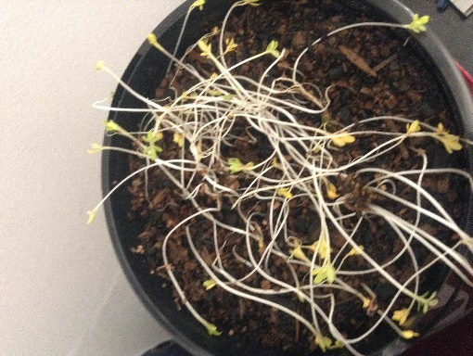Record height of each seed every morning

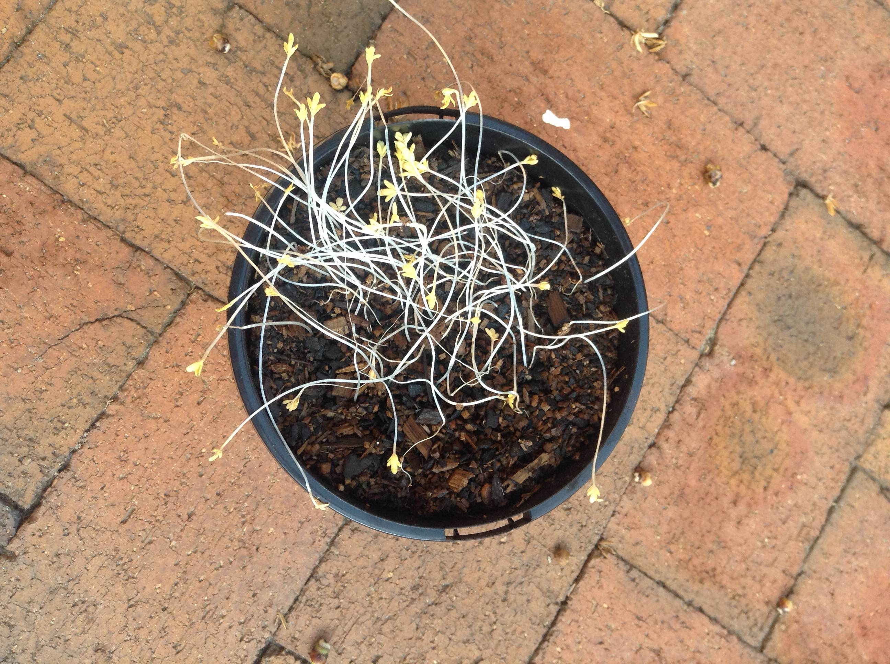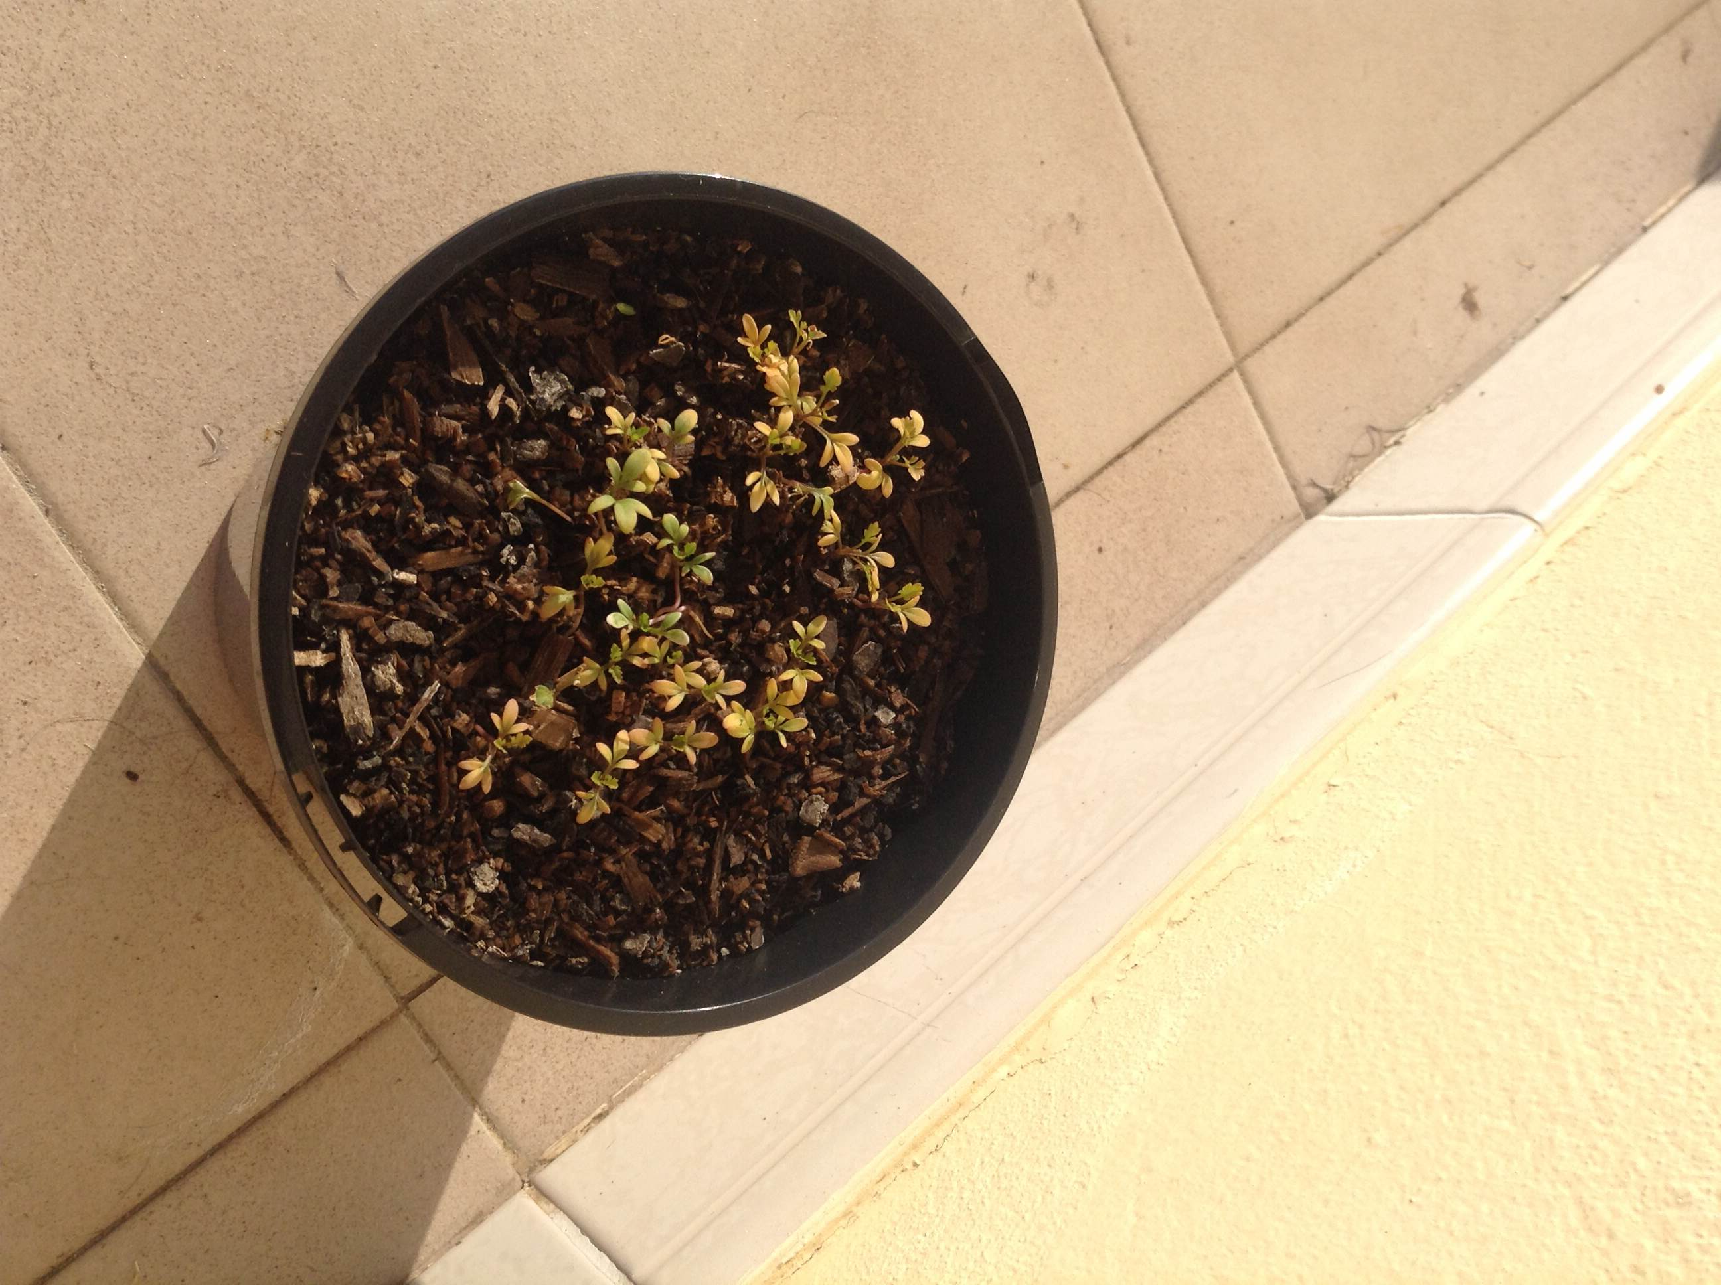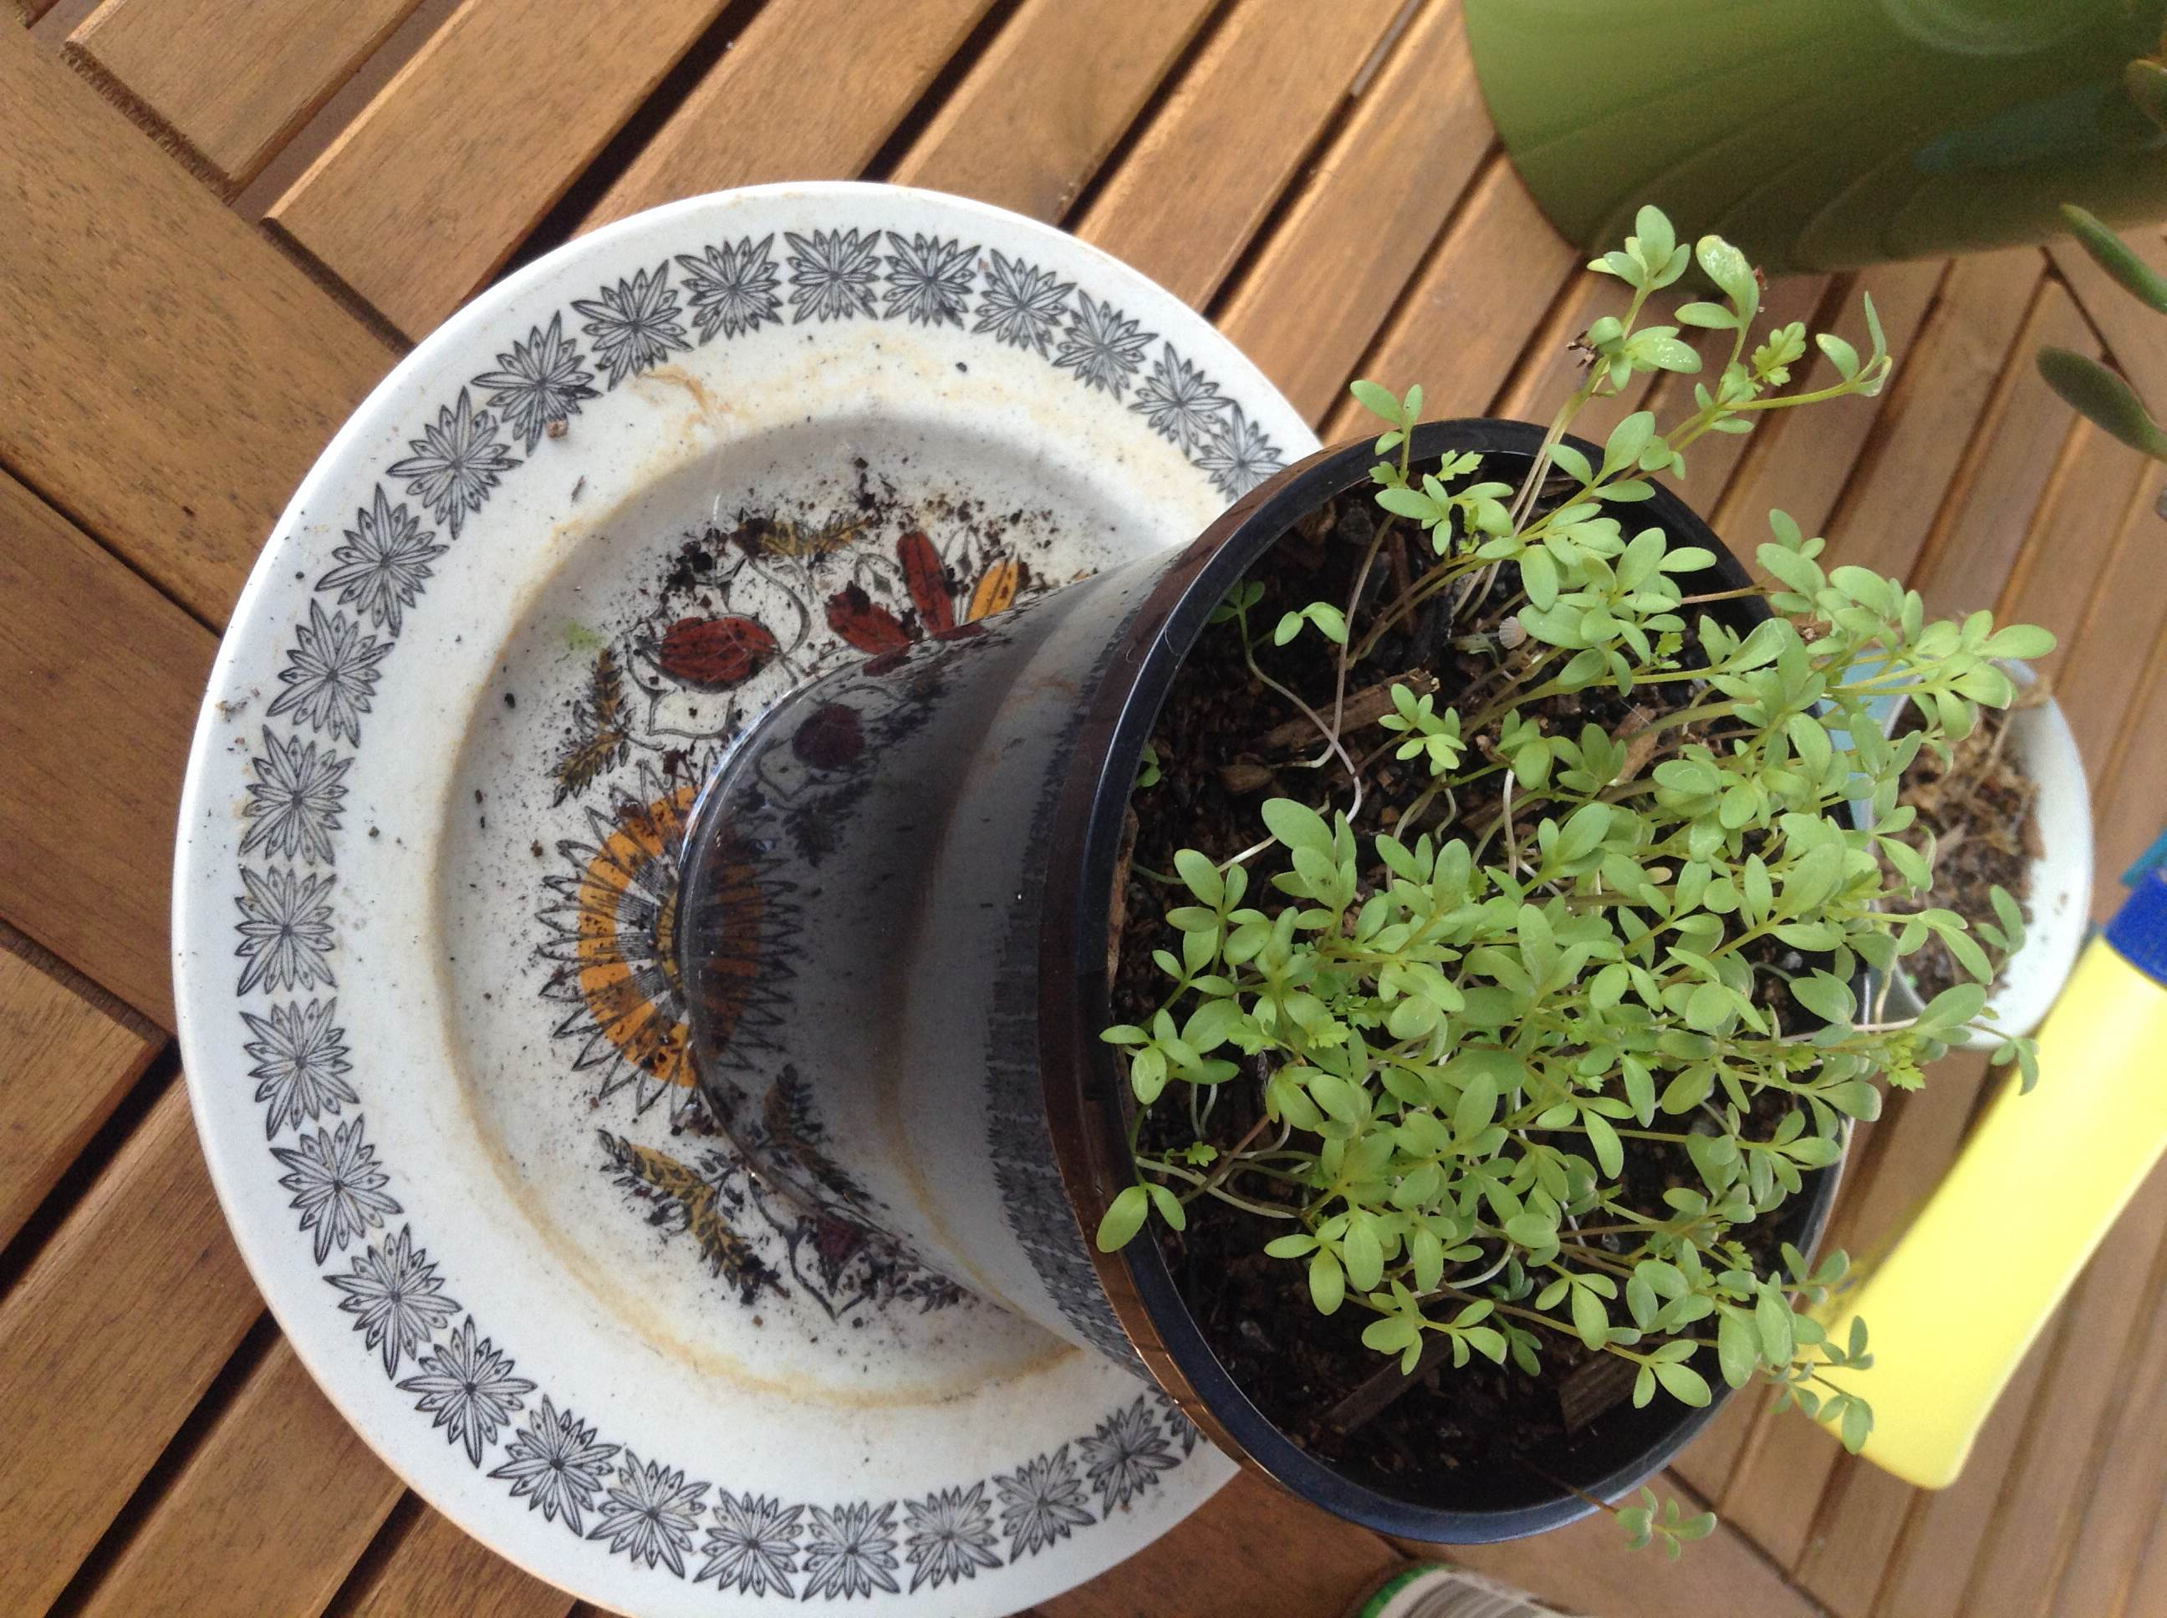

From left to right: bedroom, sun, garage, shade

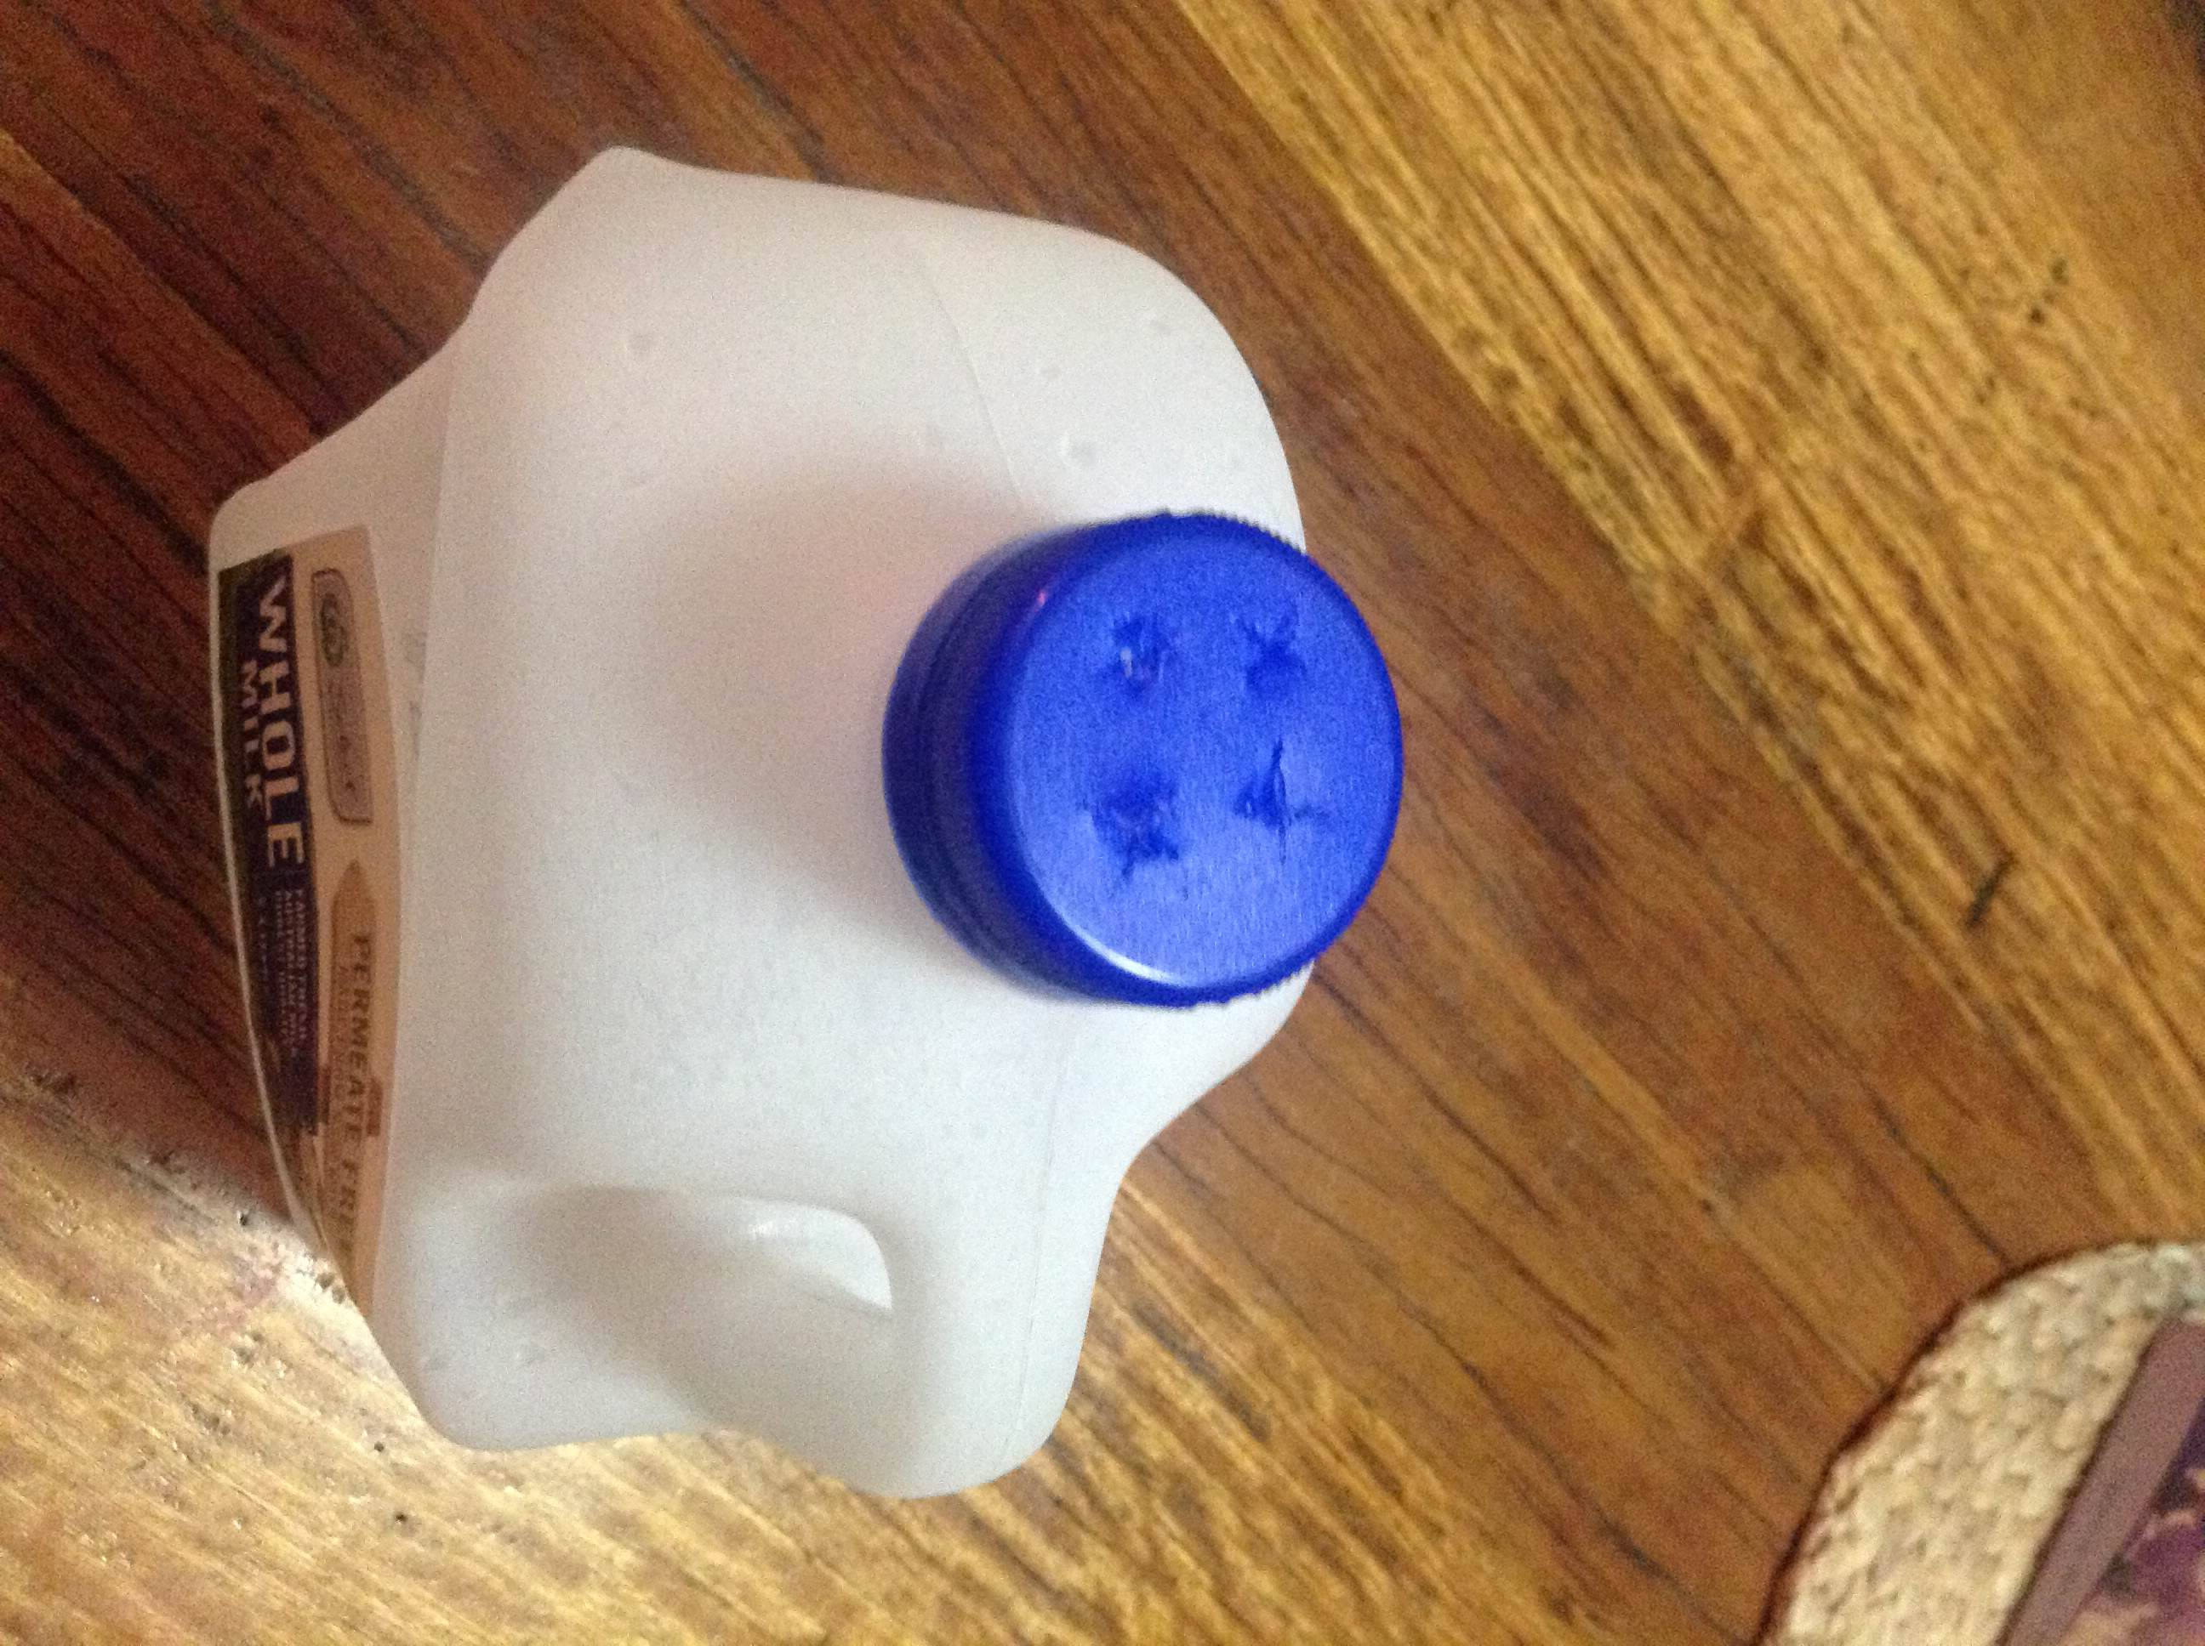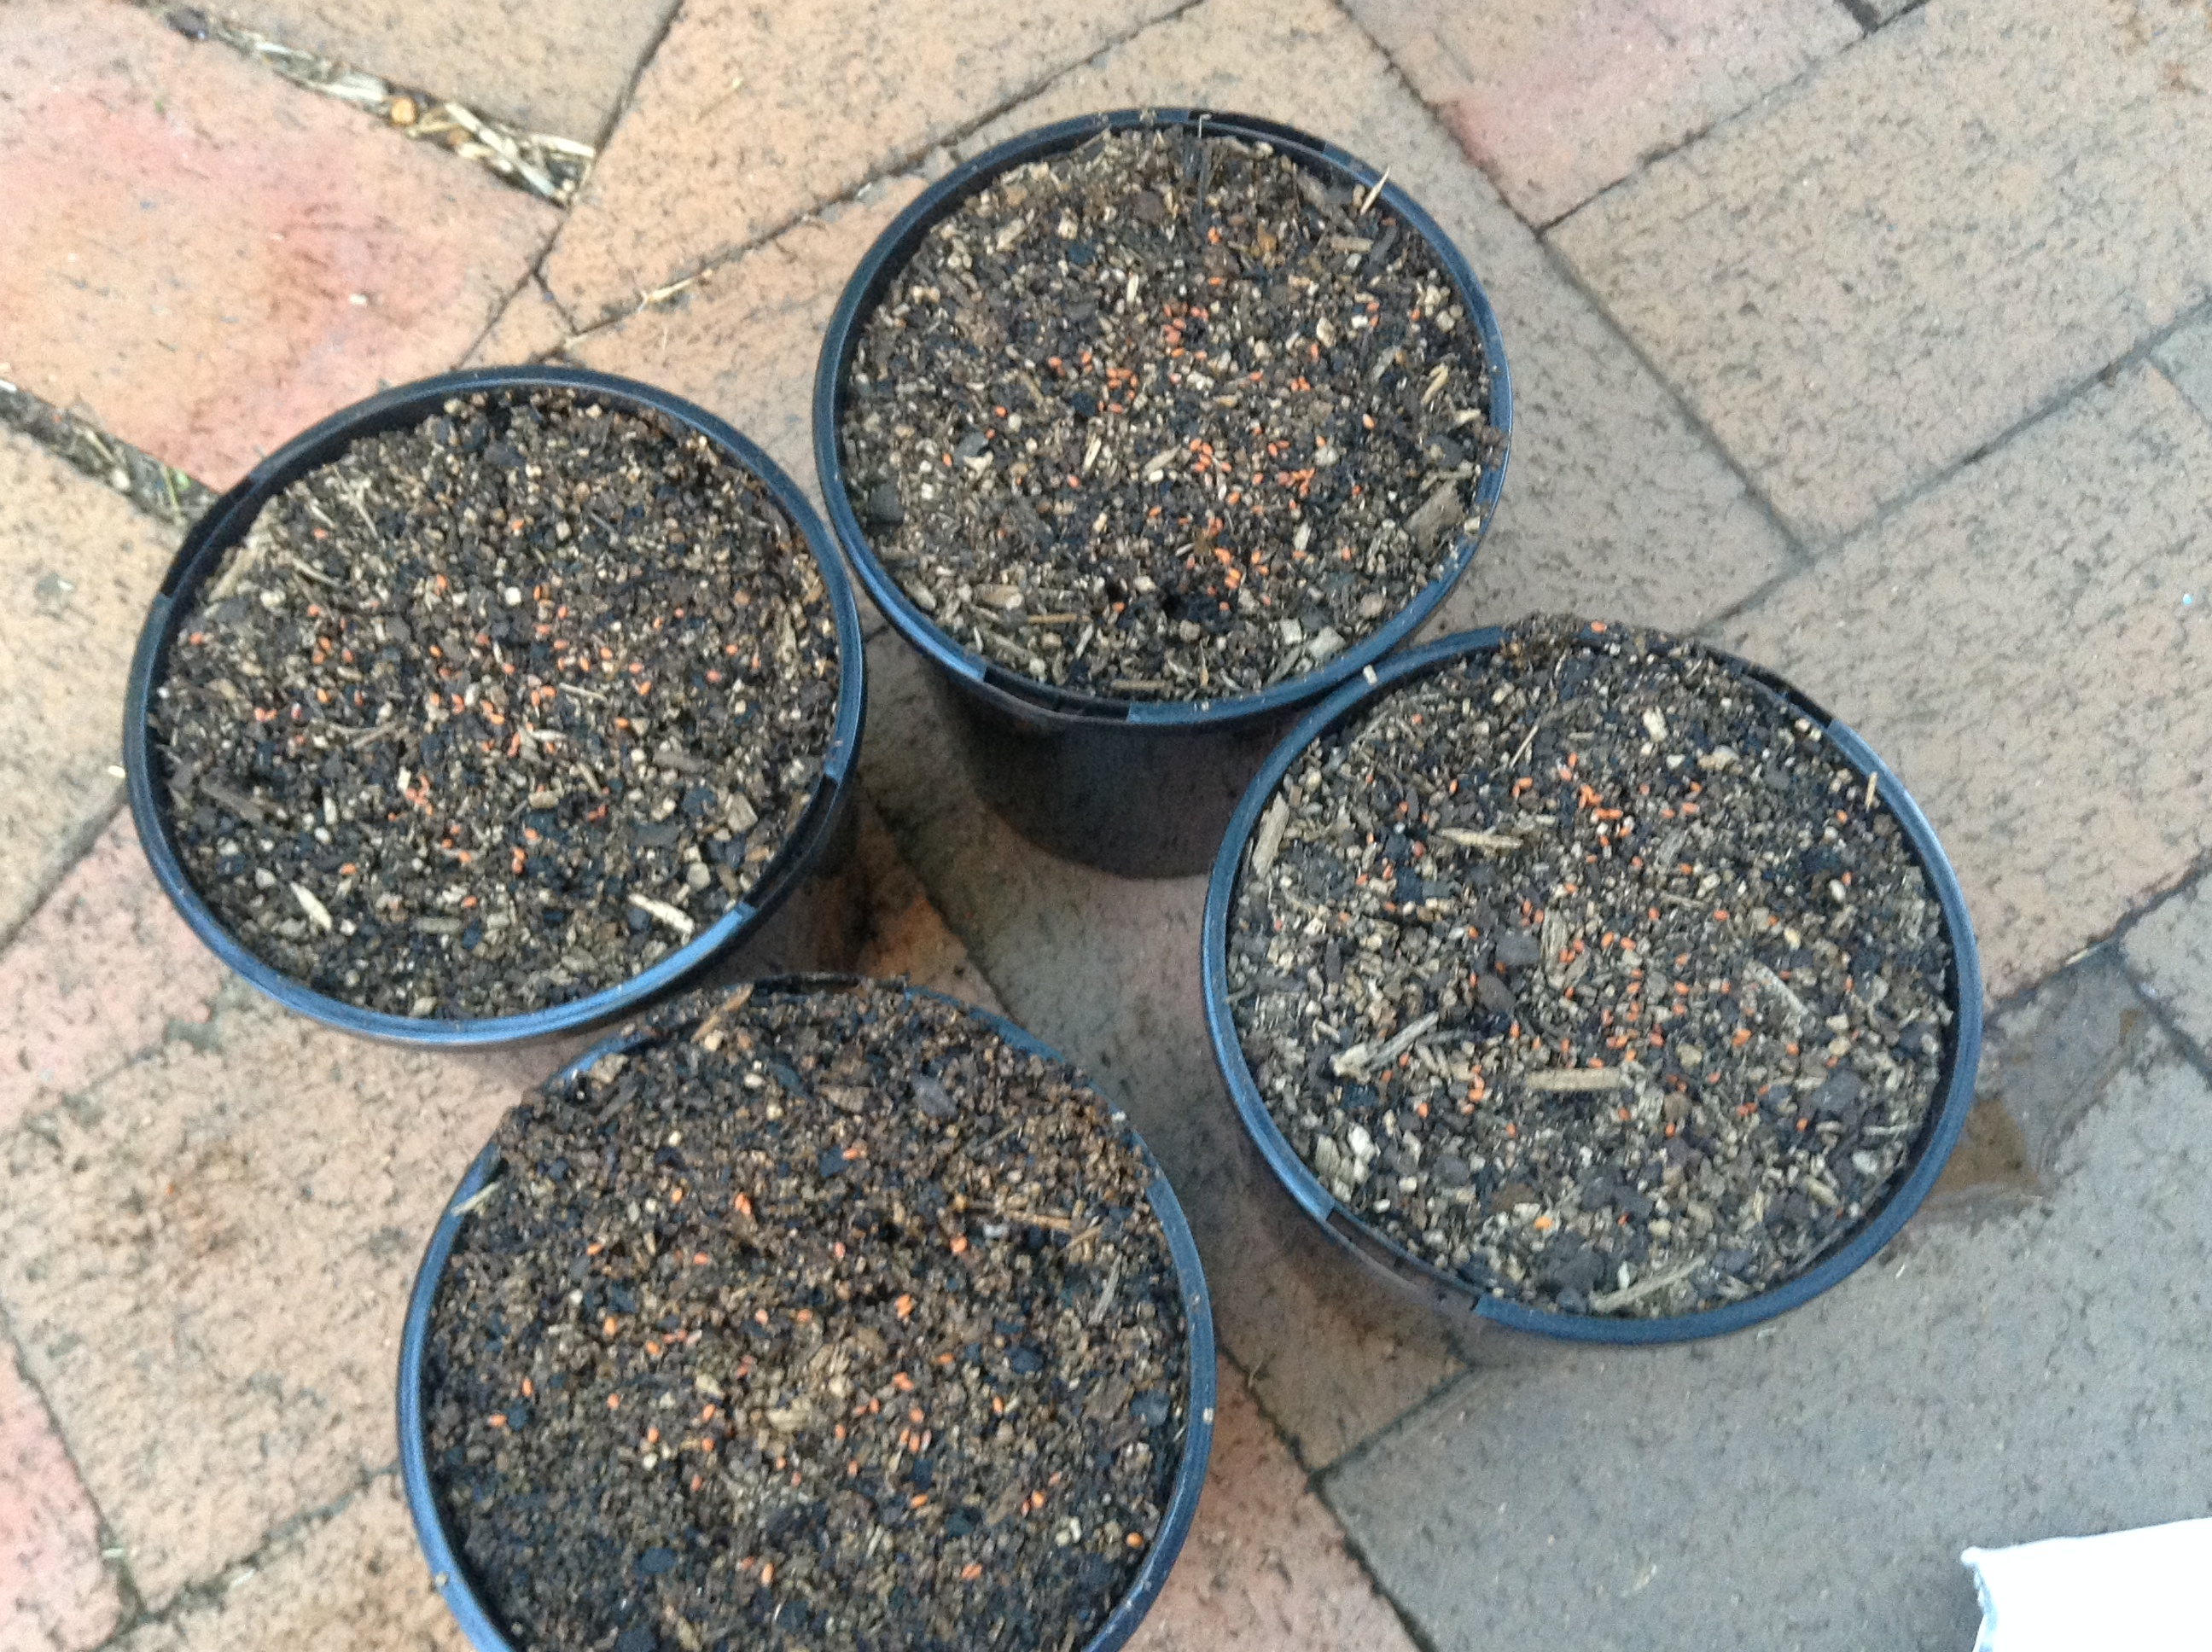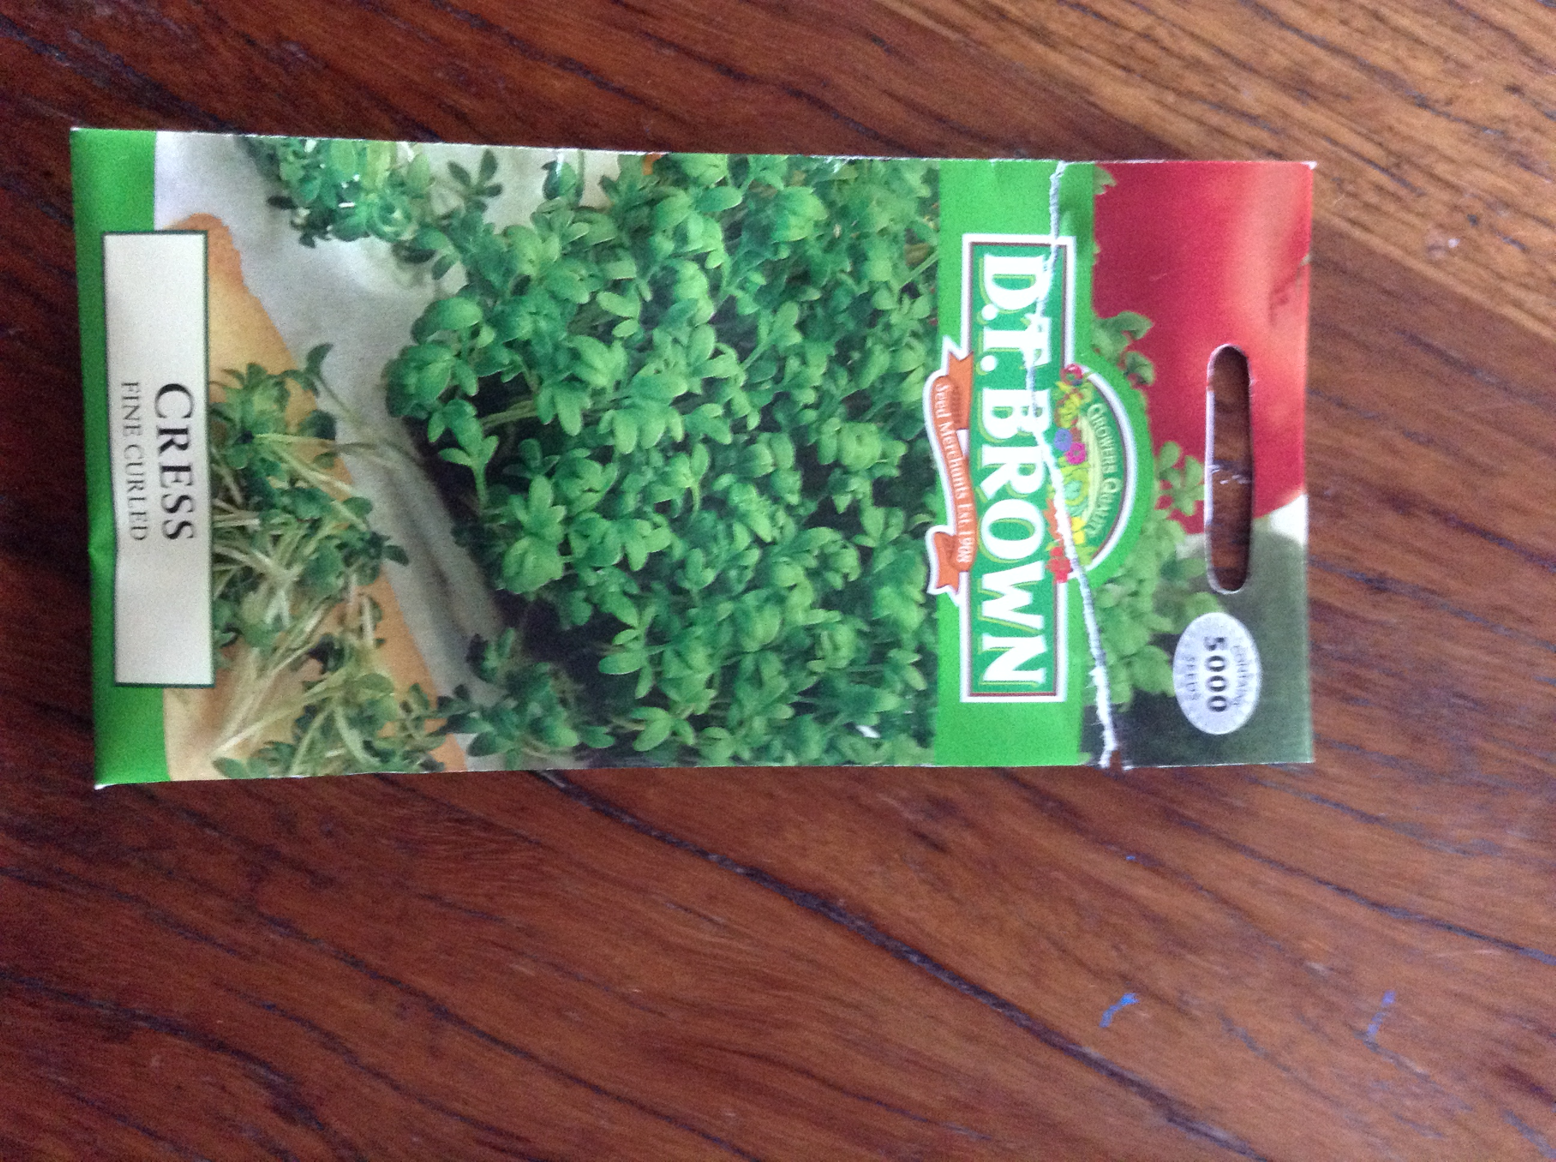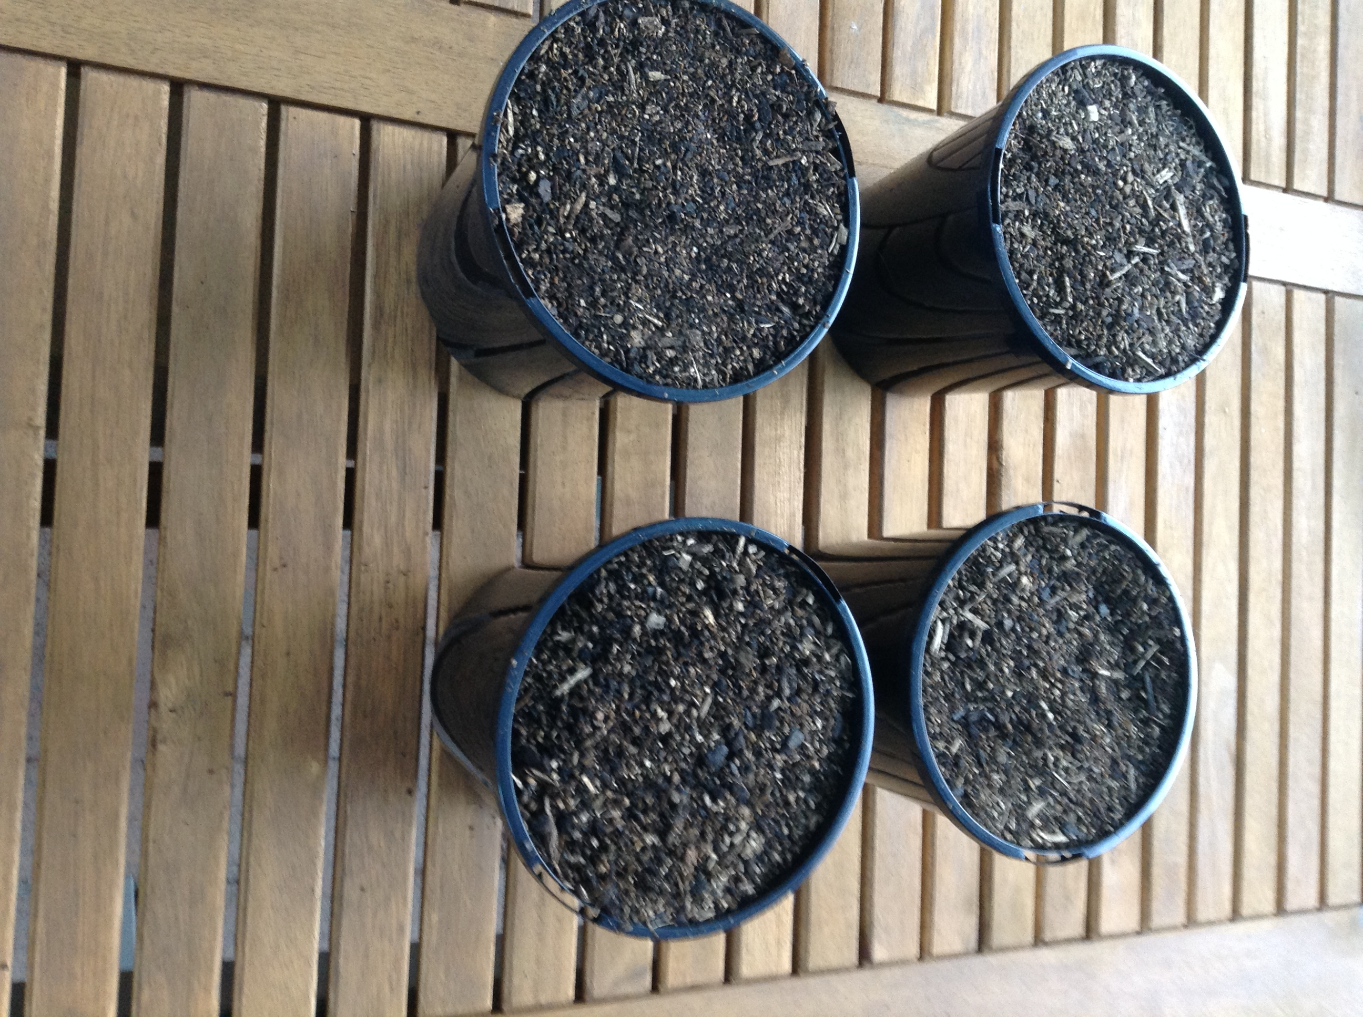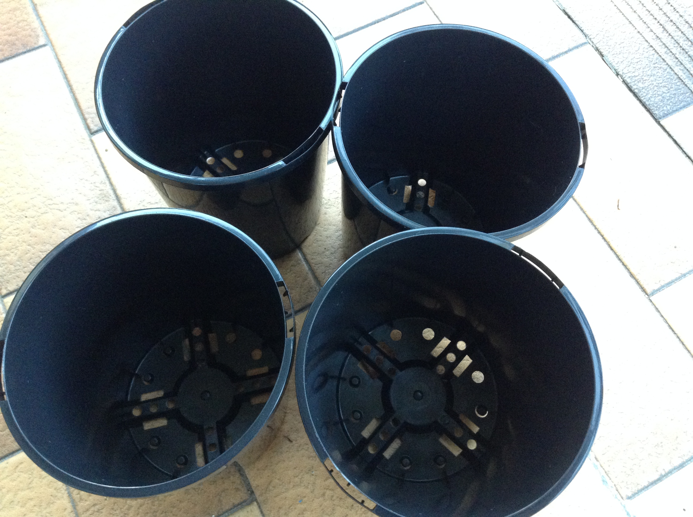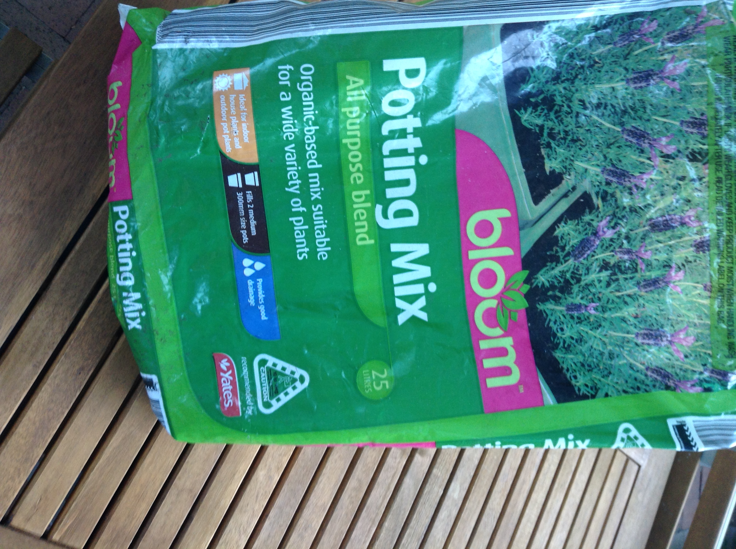

Top row left to right: Plastic pots, Blooms Potting Mix, Pots filled with potting mix.

Bottom row left to right: D.T. Brown Cress seeds, Pots filled with potting mix and cress seeds on top, milk carton watering bottle.

## Results

Height is based off of longest stalk. Whilst the cress in the bedroom collapsed the longest stalk was 7cm. The cress in the bedroom grew very quickly for 4 days and then stopped, it found it difficult to support its weight and collapsed, in the following days the stalks tangled together. The stalks were originally a pale green but very quickly went white. The cress in the garage had a very similar fate, it grew fast in attempts to find a light source but failed. The stalks also collapsed under their weight and became tangled. The garage cress was much paler, stalks were white from day one and the leaves also had a sickly yellow tinge. After the 2 week experiment the cress in the shade is in the best condition, its growth started off slow but in the last few days has accelerated. It has a healthy green tinge and bush leaves. The cress in the sun had a very shaky start, for the first three days the seeds did not open and appeared burnt and shrivelled. For 4 days the stalks continued to grow slowly but steadily. Unfortunately the sun proved too harsh for the cress, it may have survived if watered 3 times a day instead, but this would have caused complications in the experiment. Cress rely on phototropism for survival, too little and the cress shall become pale and die. Too much and the cress will burn. A shaded area is the optimum location for the growth of cress. This area received indirect sunlight which allowed for some photosynthesis to occur but prevented the soil in the pot from drying out.

## Discussion

I believe results should be repeated several times to create an average result, results will ultimately be affected by the season, whilst Cress can grow all year, an exact repeat of this experiment in August would show the cress in direct sunlight would grow best in winter. Simply due to cooler climates and less sun exposure. To ensure reliable data experiment should be repeated once each season. I believe the cress in the sun may have simply needed more water, the experiment should be repeated with additional water given to each plant.

## Conclusion

In conclusion, I believe my experiment successfully studied the effects of phototropism on the germination of seedlings, I originally stated in my hypothesis that the cress in the sun would grow the fastest, this was however incorrect, the sun was most likely too harsh for the cress.

## Bibliography

15/03/2014 - I spoke to a Bunnings employee for their opinion on fast growing plants.

15/03/2014 - <http://www.growveg.com/growblogpost.aspx?id=307> provided information on how to grow the cress.

15/03/2014 - <http://organicgardening.about.com/od/howtogrowveggies/a/How-To-Grow-Organic-Cress.htm>

17/03/2014 – My Mother assisted with the planting of the cress, She has far more experience gardening then myself.